Copy-on-Write Memory Demonstrator
Operating Systems Project Report
A Project Report Submitted in partial fulfillment of the requirements for the award of the degree of
BACHELOR OF TECHNOLOGY
In
[DEPARTMENT NAME]
By
[STUDENT NAME 1] | [ROLL NUMBER 1]
[STUDENT NAME 2] | [ROLL NUMBER 2]
[STUDENT NAME 3] | [ROLL NUMBER 3]

Under the Esteemed Guidance of
[FACULTY GUIDE NAME]
[DESIGNATION]
[DEPARTMENT NAME]
Academic Year: [ACADEMIC YEAR] Submission Date: [SUBMISSION DATE]



K L (Deemed to be) University
[DEPARTMENT NAME]
Declaration
The Project Report entitled "Copy-on-Write Memory Demonstrator" is a record of bonafide work of [STUDENT NAME 1 - ROLL NUMBER], [STUDENT NAME 2 - ROLL NUMBER], [STUDENT NAME 3 - ROLL NUMBER] submitted in partial fulfillment for the award of B.Tech in [DEPARTMENT NAME] to the University. The results embodied in this report have not been copied from any other department, university or institute.

[STUDENT NAME 1] | [ROLL NUMBER 1]
[STUDENT NAME 2] | [ROLL NUMBER 2]
[STUDENT NAME 3] | [ROLL NUMBER 3]

K L (Deemed to be) University
[DEPARTMENT NAME]
CERTIFICATE
This is to certify that the project report entitled "Copy-on-Write Memory Demonstrator" is a bonafide work done and submitted by [STUDENT NAME 1 - ROLL NUMBER], [STUDENT NAME 2 - ROLL NUMBER], [STUDENT NAME 3 - ROLL NUMBER] in partial fulfillment of the requirements for the award of the degree of BACHELOR OF TECHNOLOGY in [DEPARTMENT NAME], K L (Deemed to be University), during the academic year [ACADEMIC YEAR].

Signature of the Guide | Signature of the Course Coordinator | Signature of the HOD
[Guide name] | [Coordinator name] | [HOD name]

Date: [SUBMISSION DATE]

ACKNOWLEDGEMENT
The success of this project would not have been possible without the timely help and guidance of many people. We wish to express our sincere thanks to all those who assisted us in one way or another in the completion of this work.
We express our greatest appreciation to our Course Coordinator, [COURSE COORDINATOR NAME], and our project guide, [FACULTY GUIDE NAME], [DEPARTMENT NAME], for the valuable support, encouragement and guidance that they gave us throughout this project.
We express our gratitude to [HEAD OF DEPARTMENT NAME], Head of the [DEPARTMENT NAME], for providing us with the facilities and resources needed to complete this project.
We thank all the teaching and non-teaching staff members who assisted us directly or indirectly. Finally, we sincerely thank our parents, friends and classmates for their kind help and cooperation during our work.

[STUDENT NAME 1] [ROLL NUMBER 1]
[STUDENT NAME 2] [ROLL NUMBER 2]
[STUDENT NAME 3] [ROLL NUMBER 3]
ABSTRACT
Creating new processes quickly and using memory efficiently are central tasks of an operating system. On Linux, the fork() system call creates a child process as a duplicate of its parent, and the kernel can avoid copying all of the parent's memory immediately by using a technique called Copy-on-Write (COW). Parent and child initially share the same physical memory pages, and when either process writes to a protected shared page, the kernel can create a private copy of that page for the writing process.
This project presents the Copy-on-Write Memory Demonstrator, an educational C program that runs in user space on Linux. The program maps one page of memory with mmap() using MAP_PRIVATE | MAP_ANONYMOUS, stores the value 100 in it, creates a child with fork(), and lets the child change the value to 200. The parent waits with waitpid() and then reads the page again. The program was compiled with GCC and executed on Ubuntu 24.04 LTS running on WSL2. The observed output was 100 (initial), 100 (child before write), 200 (child after write) and 100 (parent after the child's write).
These results demonstrate process memory isolation and are consistent with Copy-on-Write behaviour. The project does not implement a custom kernel, does not directly observe physical page frames or kernel internals, and does not measure performance. The report explains the underlying theory, system calls, design, source code, execution steps, test results, limitations and possible future work.
Keywords: Operating Systems, Copy-on-Write, fork(), mmap(), virtual memory, process isolation, Linux.
INDEX
S. No. | Chapter | Topics / Subtopics | Page No.
 | Acknowledgement |  | i
 | Abstract |  | ii
1 | Introduction |  | 1
 |  | 1.1 Background of the Project | 1
 |  | 1.2 Problem Statement | 1
 |  | 1.3 Objectives of the Project | 1
 |  | 1.4 Scope of the Project | 2
2 | OS Concepts and Background Study |  | 3
 |  | 2.1 Virtual Memory and Paging | 3
 |  | 2.2 Process Creation Using fork() | 3
 |  | 2.3 Copy-on-Write Explained | 3
 |  | 2.4 Copy-on-Write Step by Step | 4
 |  | 2.5 Why Copy-on-Write Is Useful | 4
 |  | 2.6 Observing Memory Mappings in Linux | 4
3 | System Requirements |  | 5
 |  | 3.1 Hardware Requirements | 5
 |  | 3.2 Software Requirements | 5
 |  | 3.3 Operating System Environment: Ubuntu / WSL2 | 5
 |  | 3.4 Development Tools and Compilers | 6
4 | Technology and Tools Used |  | 7
 |  | 4.1 C Programming Language | 7
 |  | 4.2 GCC Compiler | 7
 |  | 4.3 Linux System Calls Used | 7
 |  | 4.4 Linux Commands and Utilities | 8
 |  | 4.5 Header Files Used | 8
5 | System Architecture and Design |  | 9
 |  | 5.1 Overall System Architecture | 9
 |  | 5.2 System Workflow | 9
 |  | 5.3 Algorithm | 10
 |  | 5.4 Flowchart | 10
 |  | 5.5 Conceptual Memory Diagram | 11
 |  | 5.6 Input and Output Design | 11
6 | Implementation |  | 12
 |  | 6.1 Source Code (cow_demo.c) | 12
 |  | 6.2 Code Explanation | 13
 |  | 6.3 Design Decisions | 13
7 | Installation, Compilation, and Execution |  | 14
 |  | 7.1 Installing the Compiler | 14
 |  | 7.2 Creating the Source File with Nano | 14
 |  | 7.3 Compiling the Program | 14
 |  | 7.4 Running the Program | 14
 |  | 7.5 Explanation of Commands | 14
 |  | 7.6 Observed Output | 15
8 | Testing and Validation, Results and Discussion |  | 16
 |  | 8.1 Testing Approach | 16
 |  | 8.2 Test Cases | 16
 |  | 8.3 Results and Discussion | 16
 |  | 8.4 Interpretation as Copy-on-Write Behaviour | 16
9 | Advantages, Applications, Limitations and Future Enhancements |  | 18
 |  | 9.1 Advantages | 18
 |  | 9.2 Applications | 18
 |  | 9.3 Limitations | 18
 |  | 9.4 Future Enhancements | 19
10 | Conclusion |  | 20
 |  | 10.1 Summary of the Project | 20
 |  | 10.2 Objectives Achieved | 20
 |  | 10.3 Learning Outcomes | 20
11 | References |  | 21
 |  | 11.1 Books | 21
 |  | 11.2 Linux Manual Pages | 21
 |  | 11.3 Online Documentation | 21

CHAPTER 1
INTRODUCTION

1.1 Background of the Project
Every modern operating system must create new processes quickly and use main memory carefully. On Linux and other UNIX-like systems, a new process is normally created with the fork() system call, which produces a child process that begins as a near-duplicate of its parent. If the kernel physically copied every memory page of the parent at the moment of fork(), process creation would be slow and memory would be wasted, especially when the child quickly replaces its program image or only reads the data it inherited.
Linux avoids much of this cost with a technique called Copy-on-Write (COW). Parent and child initially share the same physical memory pages, and those pages are protected so that a write attempt is detected by the kernel. Only when a process writes to a shared page does the kernel create a private copy of that page for the writing process. From the programmer's point of view, each process behaves as if it owns a separate copy of all memory from the very beginning.
This project, the Copy-on-Write Memory Demonstrator, is a small educational C program that makes this behaviour visible. It maps a page of memory, stores the value 100 in it, creates a child process with fork(), lets the child change the value to 200, and then shows that the parent still sees 100.

1.2 Problem Statement
Copy-on-Write happens entirely inside the kernel and is invisible to ordinary programs. Students studying process creation and virtual memory often learn the concept only as a diagram or a paragraph in a textbook, without a short, runnable program that shows the externally observable consequence: a write by one process is not seen by the other.
The problem addressed by this project is therefore to design and implement a minimal, well-explained C program for Linux that demonstrates, using real system calls, that a child process modifying a privately mapped memory page does not alter the parent's copy of that page.

1.3 Objectives of the Project
- To explain the Copy-on-Write technique and its role in fork() in simple and technically accurate language.
- To implement a working C program that uses mmap() with MAP_PRIVATE | MAP_ANONYMOUS, fork(), waitpid() and munmap().
- To initialise a memory value to 100, change it to 200 in the child process, and verify that the parent's value remains 100.
- To document the installation, compilation and execution steps on Ubuntu 24.04 LTS running on WSL2.
- To record the observed output and validate it with a structured test table.
- To provide conceptual diagrams (architecture, flowchart and memory behaviour) that help readers understand the demonstration.

1.4 Scope of the Project
The project is a working software prototype and an educational demonstration. It is a user-space C program that runs on top of the standard Linux kernel; it does not implement or modify an operating-system kernel. The program relies on the kernel's existing virtual-memory and process-management functionality.
The demonstration shows process memory isolation, which is the behaviour that Copy-on-Write must preserve. It does not directly observe physical page frames or internal kernel operations, and it does not measure execution time or memory savings. No performance improvement is claimed by this project.

CHAPTER 2
OS CONCEPTS AND BACKGROUND STUDY

2.1 Virtual Memory and Paging
Each Linux process works with its own virtual address space. The addresses used by a program are not physical RAM addresses. The kernel and the processor's memory-management hardware translate each virtual address to a physical one using page tables. Memory is managed in fixed-size blocks called pages (commonly 4096 bytes on x86-64 Linux, although the program queries the real value with sysconf(_SC_PAGESIZE)).
Because translation goes through page tables, two different processes can have virtual pages that refer to the same physical page frame, and the kernel can attach permissions (read, write, execute) to every mapping. Copy-on-Write is built on exactly these two facilities.

2.2 Process Creation Using fork()
According to the Linux manual page, fork() creates a new process by duplicating the calling process. The new process is the child and the calling process is the parent. The child has its own process ID and runs in a separate memory space. At the time of fork() the memory contents of the two processes are identical, and writes by one process do not affect the other. fork() returns the child's PID in the parent, 0 in the child, and -1 on failure; the program uses this return value to decide which code path to follow.
The manual page also notes that, on Linux, fork() is implemented using copy-on-write pages, so the only penalty it incurs is the time and memory required to duplicate the parent's page tables and to create a unique task structure for the child.

2.3 Copy-on-Write Explained
Copy-on-Write is a lazy-copying strategy: do not copy data until someone actually modifies it. After fork(), the kernel does not copy the parent's pages. Instead, the parent and child page tables point to the same physical pages, and these pages are marked so that a write causes a page fault. As long as both processes only read, they keep sharing the pages. When either process writes to a shared page, the kernel handles the resulting fault by allocating a new physical page, copying the old contents into it, and updating the writing process' page table to point to the new, writable page. The other process continues to use the original page.
For a private mapping, which is the kind used in this project, the manual page for mmap() describes the semantics as follows: updates to the mapping are not visible to other processes mapping the same file, and are not carried through to the underlying file; it is unspecified whether changes made to the file after mmap() are visible in the mapped region. For an anonymous private mapping, there is no file behind the pages at all, and each process effectively ends up with its own private data.

2.4 Copy-on-Write Step by Step
- The parent maps a page with MAP_PRIVATE | MAP_ANONYMOUS and stores 100 in it.
- The parent calls fork(). The child receives a copy of the parent's address-space description, so the same virtual address refers to the same data in both processes.
- Conceptually, the page is now shared between the two processes and protected against writing.
- The child writes 200 to the page. The write triggers a protection fault, which the kernel handles transparently.
- The kernel gives the child a private copy of the page and the write completes on that copy.
- The parent's page is unchanged, so the parent still reads 100.
This sequence is shown conceptually in Figure 5.3 of Chapter 5. The steps above describe how Linux can behave; the program in this project observes only the final, user-visible result (the child sees 200, the parent sees 100).

2.5 Why Copy-on-Write Is Useful
Copy-on-Write can reduce unnecessary memory copying. If a child process never writes to many of the inherited pages, or replaces itself soon after fork() with another program, those pages never need to be duplicated. This lowers the work done at process-creation time and can reduce physical memory use. It is important to note that this project does not measure any performance gain; the benefit described here is a general property of the technique that is documented in operating-systems literature.

2.6 Observing Memory Mappings in Linux
Linux exposes information about a process' memory mappings through /proc/PID/smaps. For each mapping, this file reports values such as the mapping's size, resident size and counts of shared and private clean/dirty pages. The file can be used by students to study how pages are shared between processes. Reading /proc/PID/smaps is not part of the present program; it is mentioned here as a reference tool and as a possible enhancement (Section 9.4).

CHAPTER 3
SYSTEM REQUIREMENTS

3.1 Hardware Requirements
The program is very small, so it needs no special hardware. The following general-purpose configuration is sufficient to repeat the demonstration:
Table 3.1: Hardware requirements
Component | Requirement
Processor | 64-bit processor with hardware virtualisation enabled (needed by WSL2)
Memory (RAM) | 4 GB or more recommended for running Windows with WSL2
Storage | A few hundred megabytes of free disk space for Ubuntu packages and the project files
Display and input | Standard monitor, keyboard and mouse

These are general guidelines for the environment, not measured minimums for the program itself.

3.2 Software Requirements
Table 3.2: Software requirements
Software | Details
Operating system (host) | Windows with the Windows Subsystem for Linux 2 (WSL2) feature enabled
Linux distribution | Ubuntu 24.04 LTS running on WSL2
Compiler | GCC (GNU Compiler Collection), installed through the build-essential package
Text editor | Nano (used in this report to create the source file)
Language | C

3.3 Operating System Environment: Ubuntu / WSL2
The program was compiled and executed in an Ubuntu 24.04 LTS terminal running on WSL2. WSL2 runs a real Linux kernel inside a lightweight virtual machine managed by Windows, so Linux system calls such as fork() and mmap() are available to programs in the usual way. The same source file is expected to work on other Linux distributions that provide GCC and the standard C library, but only the Ubuntu 24.04 LTS on WSL2 environment was used for this project.

3.4 Development Tools and Compilers
The program is compiled with GCC using the -Wall -Wextra warning options so that the compiler reports suspicious constructs. The source file is written with the Nano text editor, and the program is run from the Bash shell of the Ubuntu terminal.

CHAPTER 4
TECHNOLOGY AND TOOLS USED

4.1 C Programming Language
C was chosen because it gives direct access to POSIX and Linux system calls with very little abstraction. The demonstration needs raw pointers into a mapped memory region and direct calls to fork() and mmap(), which C expresses naturally.

4.2 GCC Compiler
GCC translates the C source file into an executable. The options used are -Wall and -Wextra, which enable common and additional warnings, and -o cow_demo, which names the output executable.

4.3 Linux System Calls Used
The demonstration uses the system calls fork(), mmap(), waitpid() and munmap(). In addition, it uses the C library function sysconf() to obtain the page size, and the _exit() call to terminate the child. Table 4.1 explains the purpose of each.
Table 4.1: Purpose of each call used in the program
Call | Purpose in this program
sysconf(_SC_PAGESIZE) | Returns the system page size, used as the length of the mapped region so that exactly one page is mapped.
mmap() | Creates a new mapping in the process' virtual address space. Here it is called with PROT_READ | PROT_WRITE and MAP_PRIVATE | MAP_ANONYMOUS and file descriptor -1, producing a private, zero-filled memory page that is not backed by a file.
fork() | Creates the child process by duplicating the calling process. Returns the child's PID in the parent, 0 in the child and -1 on error.
waitpid() | Makes the parent wait until the child has terminated, so that the parent reads the value only after the child's write and the output appears in a predictable order.
munmap() | Removes the mapping and releases the region. Called by both the parent and the child before they finish.
_exit() | Terminates the child immediately without running the parent's registered exit handlers, which is the usual practice for a forked child that does not call exec.

Flags and protections used with mmap()
- PROT_READ | PROT_WRITE: the page can be read and written.
- MAP_PRIVATE: modifications are private to the process that makes them and are not shared with other processes.
- MAP_ANONYMOUS: the mapping is not backed by any file and its contents are initialised to zero; the file descriptor argument is -1 and the offset is 0.

4.4 Linux Commands and Utilities
The commands used to set up and run the project (sudo apt, cd, nano, gcc and the program itself) are described in Chapter 7.

4.5 Header Files Used
Table 4.2: Header files included in the source code
Header | Reason
<stdio.h> | printf(), perror(), fflush()
<stdlib.h> | General utilities (included as part of the supplied source)
<unistd.h> | fork(), sysconf(), _exit(), pid_t
<sys/mman.h> | mmap(), munmap() and the PROT_* and MAP_* constants
<sys/wait.h> | waitpid()

CHAPTER 5
SYSTEM ARCHITECTURE AND DESIGN

5.1 Overall System Architecture
The demonstrator is a single user-space C program, cow_demo. When it runs, it becomes the parent process. It asks the Linux kernel for one page of private anonymous memory, stores a value in it, and calls fork() to create the child process. Both processes are ordinary user processes; all virtual-memory handling, including any Copy-on-Write work, is performed by the existing Linux kernel and is not modified by this project.
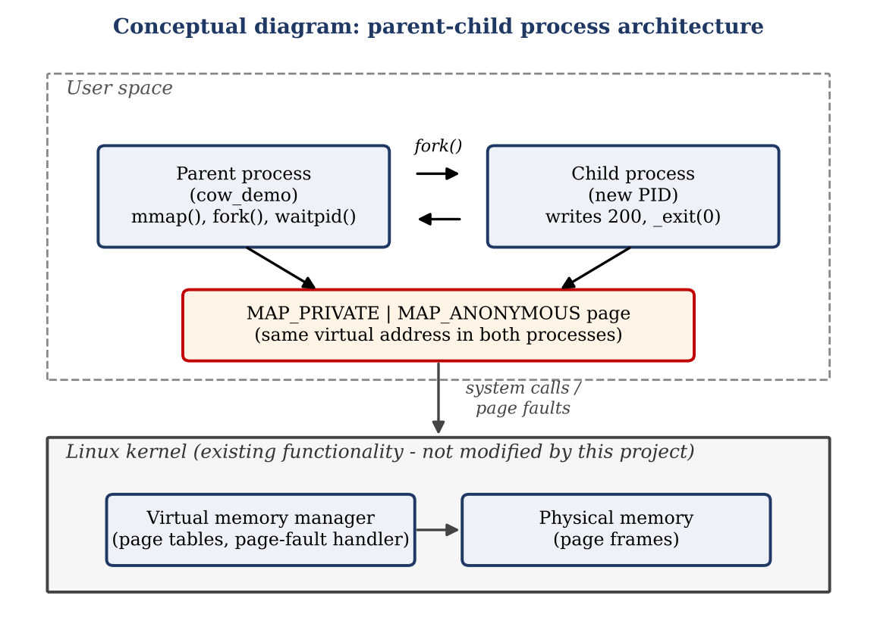
Figure 5.1: Parent-child process architecture (conceptual diagram)
Figure 5.1 is a conceptual diagram. It shows the relationship between the parent, the child and the kernel; it does not represent measured kernel data structures.

5.2 System Workflow
- The parent queries the page size and maps one private anonymous page.
- The parent writes 100 into the page and prints it.
- The parent calls fork(). The child starts with the same virtual-memory contents.
- The child prints the value it sees (100), writes 200, and prints the new value.
- The child unmaps the page and exits with _exit(0).
- The parent, which has been waiting in waitpid(), resumes, prints the value it sees (expected 100), unmaps the page and exits.

5.3 Algorithm
Algorithm: Copy-on-Write demonstration
- Start.
- Let size be the system page size from sysconf(_SC_PAGESIZE).
- Call mmap() for size bytes with PROT_READ | PROT_WRITE and MAP_PRIVATE | MAP_ANONYMOUS. If it returns MAP_FAILED, print an error with perror() and stop with status 1.
- Store 100 in the mapped integer and print "Initial value". Flush standard output.
- Call fork(). If it returns a negative value, print an error, unmap the page and stop with status 1.
- If the return value is 0 (child): print the value ("Child before write"), store 200, print the value ("Child after write"), unmap the page and call _exit(0).
- Otherwise (parent): call waitpid() for the child, print the value ("Parent after child write"), and unmap the page.
- Stop with status 0.

5.4 Flowchart
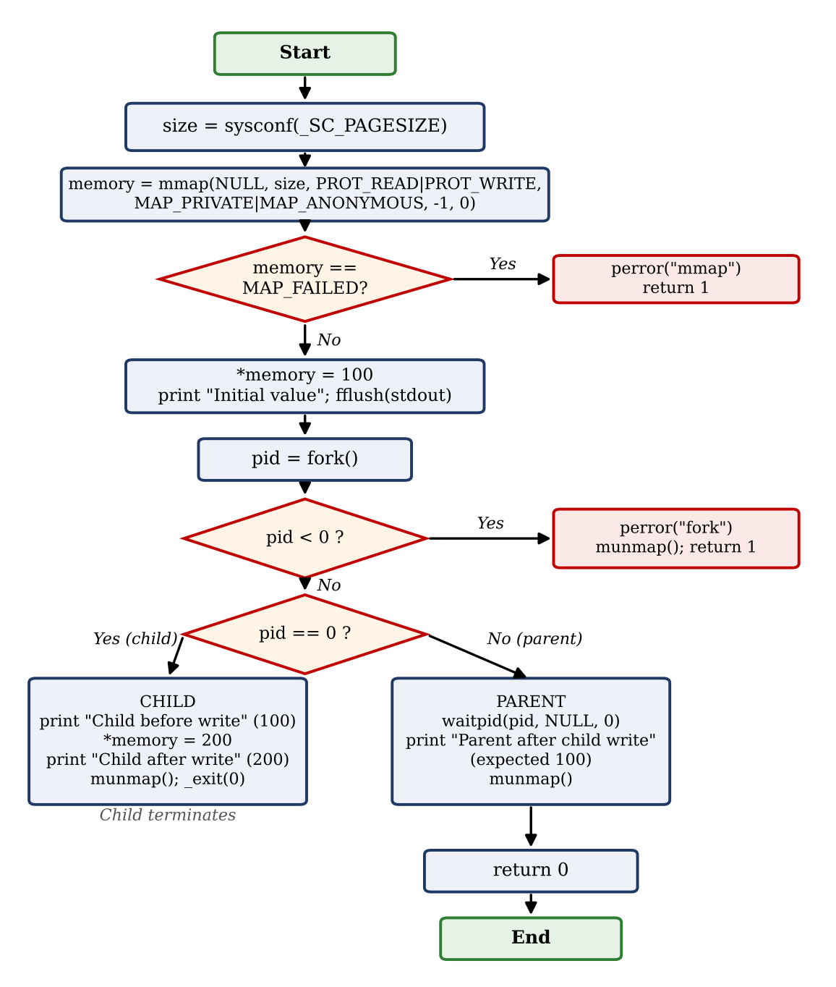
Figure 5.2: Flowchart of program execution

5.5 Conceptual Memory Diagram
Figure 5.3 illustrates, conceptually, what Linux can do with the page after fork(). Panel (a) shows the initial state in which the parent's and child's virtual pages refer to the same physical frame. Panel (b) shows the state after the child writes 200, when the child has been given a private copy.
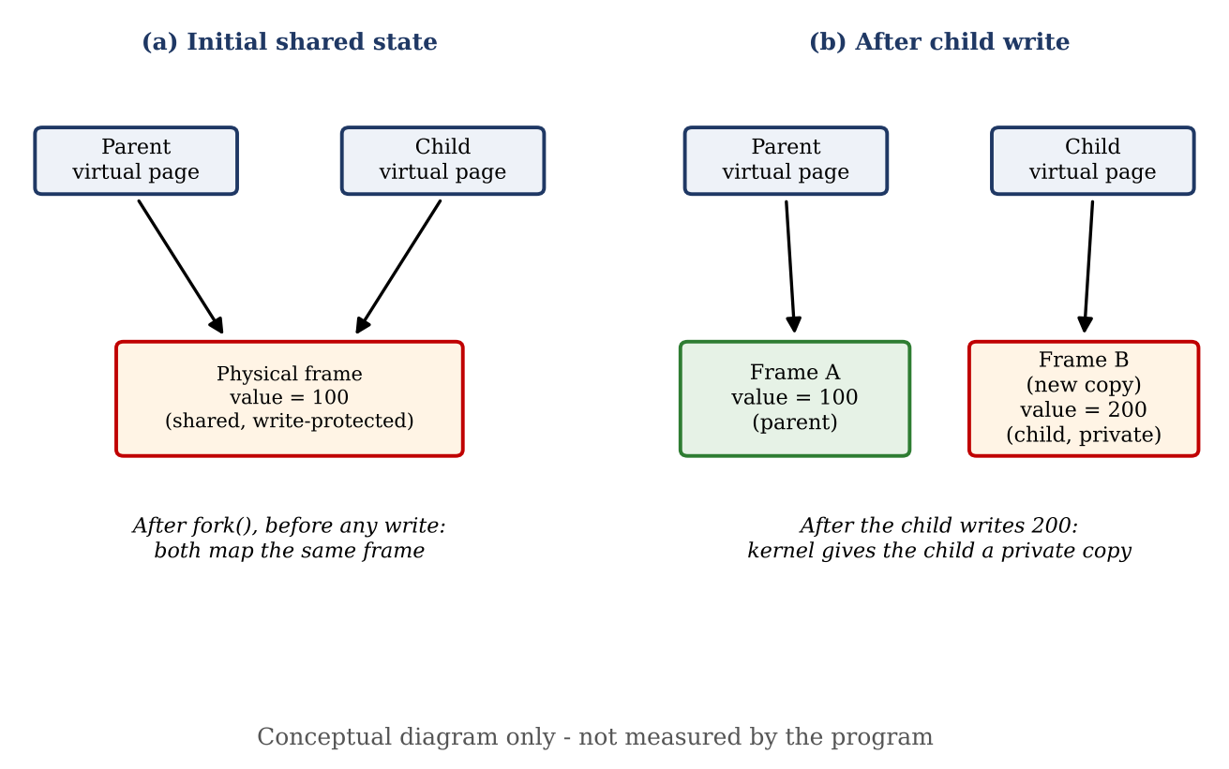
Figure 5.3: Conceptual memory behaviour before and after the child's write
Note: Figure 5.3 is a conceptual illustration of the Copy-on-Write technique. The demonstration program does not directly measure physical page frames, page tables or internal kernel operations; it observes only the values visible to each process.

5.6 Input and Output Design
The program takes no input from the user. Its output consists of four lines printed to the terminal, one for each observation point: the initial value, the value seen by the child before its write, the value seen by the child after its write, and the value seen by the parent after the child has finished.

CHAPTER 6
IMPLEMENTATION

6.1 Source Code (cow_demo.c)
The complete source code of the demonstrator is given below. It is saved as cow_demo.c.
Listing 6.1: cow_demo.c
#include <stdio.h>
#include <stdlib.h>
#include <unistd.h>
#include <sys/mman.h>
#include <sys/wait.h>

int main(void) {
long size = sysconf(_SC_PAGESIZE);

int *memory = mmap(NULL, size,
PROT_READ | PROT_WRITE,
MAP_PRIVATE | MAP_ANONYMOUS,
-1, 0);

if (memory == MAP_FAILED) {
perror("mmap");
return 1;
}

*memory = 100;

printf("Initial value: %d\n", *memory);
fflush(stdout);

pid_t pid = fork();

if (pid < 0) {
perror("fork");
munmap(memory, size);
return 1;
}

if (pid == 0) {
printf("Child before write: %d\n", *memory);
*memory = 200;
printf("Child after write: %d\n", *memory);
munmap(memory, size);
_exit(0);
} else {
waitpid(pid, NULL, 0);
printf("Parent after child write: %d\n", *memory);
munmap(memory, size);
}

return 0;
}

6.2 Code Explanation
Part of the code | Explanation
#include lines | Bring in declarations for input/output, POSIX calls, memory mapping and process waiting.
sysconf(_SC_PAGESIZE) | Reads the page size into size, so that exactly one page is mapped.
mmap(...) | Requests a private, anonymous, readable and writable page. The returned address is stored in the integer pointer memory. MAP_FAILED signals an error.
*memory = 100; | Writes the initial value into the mapped page before the child exists.
printf + fflush(stdout) | Prints the initial value and flushes the output buffer so that buffered text is not duplicated into the child when fork() copies the process.
fork() | Splits execution into two processes. pid < 0 means failure; pid == 0 identifies the child; otherwise the code is running in the parent.
Child branch | Prints the inherited value (100), assigns 200, prints it again, unmaps the page and ends with _exit(0).
Parent branch | Waits for the child with waitpid(), prints its own value of the page and unmaps it.

6.3 Design Decisions
- Anonymous private mapping instead of a global variable: using mmap() makes the page explicit and shows the exact flags that control sharing behaviour.
- `fflush(stdout)` before `fork()`: prevents text still waiting in the output buffer from being written twice, once by each process.
- `waitpid()` in the parent: guarantees that the parent reads the value only after the child has finished, so the output order is deterministic.
- Error checking: both mmap() and fork() are checked and reported with perror().
- `munmap()` in both processes: each process releases its own view of the mapping before finishing.

CHAPTER 7
INSTALLATION, COMPILATION, AND EXECUTION

7.1 Installing the Compiler
Open the Ubuntu 24.04 LTS terminal in WSL2 and install the compiler tools if they are not already present:
sudo apt update
sudo apt install build-essential -y

7.2 Creating the Source File with Nano
Create the project directory (if it does not exist), move into it, and open a new file in Nano:
mkdir -p ~/cow-memory-demo
cd ~/cow-memory-demo
nano cow_demo.c

Then follow these steps inside Nano:
- Type or paste the complete source code from Listing 6.1 into the editor.
- Press Ctrl + O (Write Out) to save the file.
- Nano shows the file name cow_demo.c. Press Enter to confirm.
- Press Ctrl + X to exit Nano and return to the shell prompt.
- Optionally, type ls to confirm that cow_demo.c exists in the directory.

7.3 Compiling the Program
From inside the project directory, compile the source file:
gcc -Wall -Wextra cow_demo.c -o cow_demo

7.4 Running the Program
./cow_demo

7.5 Explanation of Commands
Table 7.1: Commands and their meaning
Command | Explanation
sudo apt update | Refreshes the list of available packages from the Ubuntu repositories. sudo runs the command with administrator rights.
sudo apt install build-essential -y | Installs GCC, make and the standard C library headers. -y answers "yes" to the confirmation prompt automatically.
mkdir -p ~/cow-memory-demo | Creates the project directory in the home folder; -p prevents an error if it already exists.
cd ~/cow-memory-demo | Changes the current directory to the project folder.
nano cow_demo.c | Opens (or creates) the source file in the Nano text editor.
gcc -Wall -Wextra cow_demo.c -o cow_demo | Compiles cow_demo.c into an executable named cow_demo, with common and extra compiler warnings enabled.
./cow_demo | Runs the executable from the current directory.

7.6 Observed Output
The program was successfully compiled and executed in Ubuntu 24.04 LTS on WSL2. The observed output was:
Initial value: 100
Child before write: 100
Child after write: 200
Parent after child write: 100

[Insert screenshot of the terminal showing compilation and execution here]
Figure 7.1: Terminal screenshot of compilation and execution (to be inserted by the student)

CHAPTER 8
TESTING AND VALIDATION, RESULTS AND DISCUSSION

8.1 Testing Approach
The program was tested by compiling it with -Wall -Wextra and running it in the Ubuntu 24.04 LTS terminal on WSL2. The four printed values were compared with the expected values defined by the design of the demonstration.

8.2 Test Cases
Table 8.1: Test cases and results
Test No. | Test case | Expected | Observed | Status
1 | Initial memory value | 100 | 100 | Passed
2 | Child value before modification | 100 | 100 | Passed
3 | Child value after modification | 200 | 200 | Passed
4 | Parent value after child modification | 100 | 100 | Passed

8.3 Results and Discussion
All four test cases passed. The child process, created by fork(), inherited the value 100 that the parent had stored. After the child wrote 200 to the same virtual address, the child observed 200, but the parent, which resumed after the child ended, still observed 100.
This result demonstrates process memory isolation: a write made by the child to a private mapping did not change the parent's data, even though the two processes used the same virtual address. This is the guarantee that Linux gives to processes created by fork().

8.4 Interpretation as Copy-on-Write Behaviour
The observed output is consistent with Copy-on-Write behaviour. Linux is documented to implement fork() with copy-on-write pages, so the isolation seen in the output is obtained without the kernel copying the parent's memory eagerly. Under this technique, the child's write causes the kernel to create a private copy of the page for the child, and the parent's page remains unchanged.
It is important to state what the program does and does not show. The program shows the result that the user can observe: the parent's value stays 100 while the child's value becomes 200. Because the program runs in user space, it cannot directly observe whether, when or how the kernel copied a physical page; this would require additional tools such as /proc/PID/smaps. In addition, the same output would be seen for any correct implementation of process isolation. The test therefore validates the isolation guarantee and is consistent with, but does not by itself prove, the internal Copy-on-Write mechanism. No timing or memory-usage measurements were made, and no performance improvement is claimed.

CHAPTER 9
ADVANTAGES, APPLICATIONS, LIMITATIONS AND FUTURE ENHANCEMENTS

9.1 Advantages

Advantages of the Copy-on-Write technique
- Avoids copying memory pages that are never modified, which can reduce unnecessary memory copying.
- Allows fast process creation because page tables, rather than all page contents, are duplicated.
- Lets parent and child share read-only data until one of them needs a private copy.

Advantages of this demonstrator
- Very short and easy to read, so it is suitable for beginners.
- Uses real Linux system calls instead of a simulation.
- Includes error checking and clean-up with munmap().
- Produces a clear, deterministic four-line output.

9.2 Applications
- Teaching process creation, virtual memory and memory isolation in an Operating Systems course.
- Laboratory demonstrations of fork() and mmap() semantics.
- A starting point for experiments with /proc/PID/smaps and other Linux memory-inspection tools.
- The general Copy-on-Write idea is used in operating systems and other software for efficient process creation and data duplication.

9.3 Limitations
- The program shows only the user-visible result. It does not observe physical page frames, page faults or kernel internals.
- It does not measure execution time or memory usage, so it makes no performance claim.
- It demonstrates a single page and a single write by a single child process.
- The program is a user-space program for Linux; it does not implement a custom kernel and is not portable to systems without these calls.
- The child ends with _exit(), which does not flush standard I/O buffers. The output was observed in an interactive terminal, where output is line-buffered. If the output is redirected to a file or pipe, the child's lines could be lost unless fflush(stdout) is added before _exit(0).

9.4 Future Enhancements
- Read /proc/PID/smaps (and related fields such as private and shared page counts) before and after the child's write to observe the mapping state.
- Extend the demonstration to many pages and to additional child processes.
- Compare the behaviour of MAP_PRIVATE and MAP_SHARED mappings to show the contrast between private and shared memory.
- Measure fork() time and memory use in a controlled experiment, if a performance study is desired.
- Add a menu or command-line options to choose the written value or the number of pages.

CHAPTER 10
CONCLUSION

10.1 Summary of the Project
The Copy-on-Write Memory Demonstrator is a working C program that uses mmap(), fork(), waitpid() and munmap() to show that a child process can modify a privately mapped page without affecting its parent. The program was successfully compiled with GCC and executed on Ubuntu 24.04 LTS running on WSL2, producing the expected output: the initial value 100, the child's values 100 and 200, and the parent's unchanged value 100.

10.2 Objectives Achieved
- Copy-on-Write and its relation to fork() were explained in simple and accurate language.
- The demonstrator was implemented and executed successfully.
- The installation, compilation and execution steps were documented.
- All four test cases passed and the results were interpreted as process memory isolation consistent with Copy-on-Write behaviour.
- Conceptual diagrams were provided and clearly labelled as conceptual.

10.3 Learning Outcomes
Through this project the team gained practical experience with Linux system calls, process creation, private memory mappings and the interpretation of observed program output. The project also showed the importance of describing precisely what a demonstration does and does not prove.

CHAPTER 11
REFERENCES

11.1 Books
- A. Silberschatz, P. B. Galvin and G. Gagne, Operating System Concepts, 10th ed., Wiley, 2018.
- A. S. Tanenbaum and H. Bos, Modern Operating Systems, 4th ed., Pearson, 2014.
- M. Kerrisk, The Linux Programming Interface, No Starch Press, 2010.
- R. Love, Linux Kernel Development, 3rd ed., Addison-Wesley, 2010.

11.2 Linux Manual Pages
- Linux man-pages project, fork(2): https://man7.org/linux/man-pages/man2/fork.2.html
- Linux man-pages project, mmap(2) and munmap(2): https://man7.org/linux/man-pages/man2/mmap.2.html
- Linux man-pages project, wait(2) and waitpid(2): https://man7.org/linux/man-pages/man2/wait.2.html
- Linux man-pages project, proc_pid_smaps(5): https://man7.org/linux/man-pages/man5/proc_pid_smaps.5.html
- Linux man-pages project, sysconf(3): https://man7.org/linux/man-pages/man3/sysconf.3.html

11.3 Online Documentation
- Microsoft, Windows Subsystem for Linux documentation: https://learn.microsoft.com/en-us/windows/wsl/
- GNU Project, GCC online documentation: https://gcc.gnu.org/onlinedocs/
Note: any research papers consulted by the team may be added as an additional subsection before submission.

